**SYMBIOSIS UNIVERSITY OF APPLIED SCIENCES**



**Subject: Internet of Things**

**Subject Code: BTCS0602**

**Program: Bachelor of Technology**

**Branch: CSIT (VI)**

**Submitted to: Submitted by:**

Mr. Ishwarlal RathodRishabh Verma

(2019BTCS063)

Shreyasi Gour

(2019BTCS077)

Unnati Dodiya

(2019BTCS083)

Yash Gupta

(2019BTCS088)

**CERTIFICATE**

*This is to certify that* ***Rishabh Verma (2019BTCS0),******Shreyasi Gour (2019BTCS077), Unnati Dodiya(2019BTCS083) and Yash Gupta (2019BTCS088),*** *students of Bachelor of Technology,3rd year, 6th semester (Computer Science and Information Technology), have successfully completed their skill project on Internet of Things namely* ***“IoT Based Smart Trash Bin using NodeMCU”*** *as a partial fulfilment of the subject Internet of Things.*

**Mr. Ishwarlal Rathod** (Project Guide)

**INDEX**

1. ABSTRACT 3

2. INTRODUCTION 4

3. BLOCK DIAGRAM 5

4.WORKING 6

5.COMPONENT DETAILS 7

5.1 NODEMCU ESP8266 8

5.2 ULTRASONIC SENSOR 8

5.3 JUMPER WIRES 9

6. SOFTWARE 10

a. ARDUINO 1.8.9 11

b. BLYNK APP 11

7. SOFTWARE INSTALLATION 12

8. TESTING OF COMPONENTS 14

9. PROBLEMS FACED 16

10. EXPERIMENTATION 16

11. APPENDIX 18

12. CONCLUSION 19

13. REFERENCES 20

# ABSTRACT

Nowadays certain actions are taken to improve the level of cleanliness in the country. People are getting more active in doing all the things possible to clean their surroundings. Various movements are also started by the government to increase cleanliness. We will try to build a system which will notify the corporations to empty the bin on time. In this system, we will put a sensor on top of the garbage bin which will detect the total level of garbage inside it and when the item is brought near the dustbin the lid will automatically open. When the garbage will reach the maximum level, a notification will be sent to the corporation's office, then the employees can take further actions to empty the bin. This system will help in cleaning the city in a better way. By using this system people do not have to check all the systems manually but they will get a notification when the bin will get filled.

# INTRODUCTION

Waste management is effective way of reducing dumped trash. Unfortunately, these practices are not widely implemented in the country. People have been negligent when it comes to proper waste disposal, ignoring labels and throwing recyclables that can still be reused. Most are unaware or choose to ignore the fact the waste segregation and recycling can reduce cost, reduce drain in our resources, and lessen the waste being produced. This study aims to automate waste segregation and implement a waste delivery system that would minimize human interference in the waste collecting and segregation process based on “Internet of Things” (IOT). So for smart lifestyle, cleanliness is needed, and cleanliness is begins with Garbage Bin. This project will helps to eradicate or minimize the garbage disposal problem.

An internet connection is a wonderful thing, it gives us all sorts of benefits that just weren’t possible before. If you’re old enough, think of your cell phone before it was a smartphone. You could call and you could text, sure, but now you can read any book, watch any movie, or listen to any song all in the palm of your hand.

The point is that connecting things to the internet yields many amazing benefits. We’ve all seen these benefits with our smartphones, laptops, and tablets, but this is true for everything else too. And yes, we do mean everything.

The Internet of Things is actually a pretty simple concept, it means taking all the physical places and things in the world and connecting them to the internet.

This project is about smart way of collecting the garbage. A system is designed by automatic detection of the level of garbage when the sensor senses it. It tells us that whether the trash can is empty or full through the webserver and you can know the status of your ‘Trash Can’ or 'Dumpsters' from anywhere in the world over the Internet. It will be very useful and can be installed in the Trash Cans at public places as well as at home.

This project is a very basic example of Internet of Things. It actually gives data about a dustbin whether its lid is open or not. It has an ultrasonic sensor which is used to sense the trash near the dustbin. The closer the ultrasonic sensor is to the trash the more the dustbin’s lid will open. The components were really budget friendly and the device can be used as a product.

# BLOCK DIAGRAM

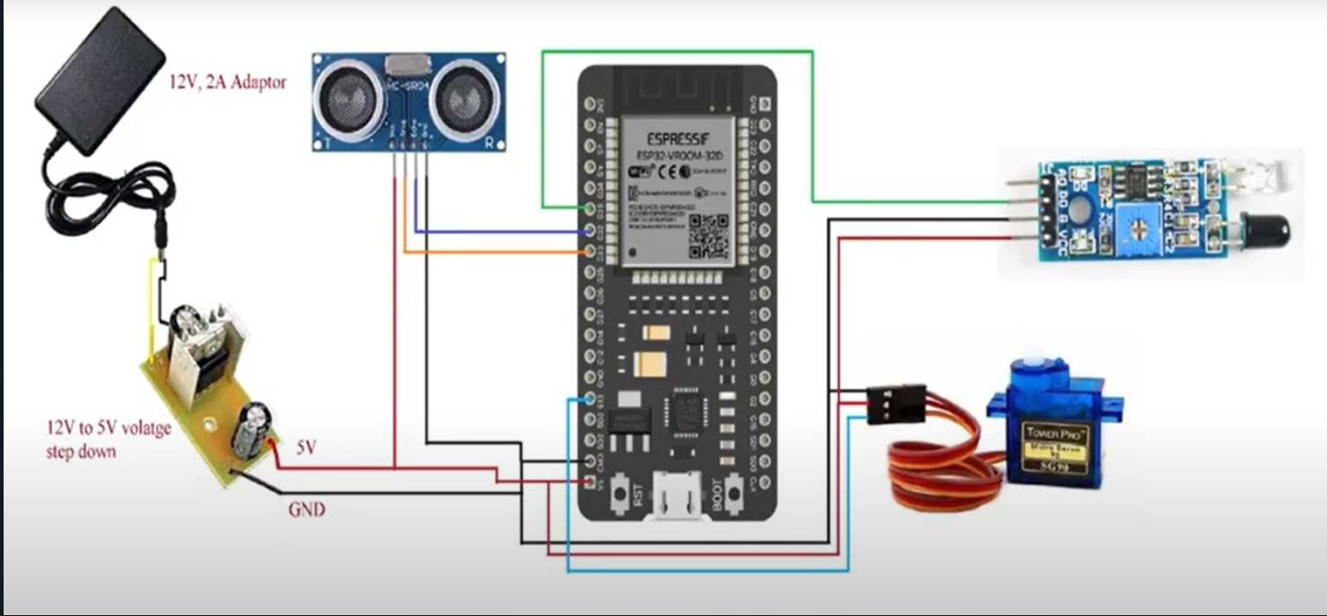

Fig 1: Block Diagram

# 4.WORKING

Steps of working: -

1. The sensor system can be placed in any dustbin. It consists of a ultrasonic sensor which senses the distance between the lid of the bin and the trash.
2. The sensor is connected to a NodeMCU which is further connect to an internet hotspot.
3. Whenever the trash is near to the sensor it senses the distance and gives notification to the user that the lid is open with what degree of motor rotation.

# 5.COMPONENT DETAILS

## NODEMCU ESP8266

ESP8266 is a Wi-Fi module which will give your projects access to Wi-Fi or internet. It is a very cheap device but it will make your projects very powerful. It can communicate with any microcontroller and make the projects wireless. It is in the list of most leading devices in the IOT platform. It runs on 3.3V and if you will give it 5V then it will get damage. The ESP8266 has 8 pins; the VCC and CH-PD will be connected to the 3.3V to enable the wifi. The TX and RX pins will be responsible for the communication of ESP8266 with the Arduino. The RX pin works on 3.3V so you will have to make a voltage divider for it as it used for implementation. ESP8266 is shown in figure 3

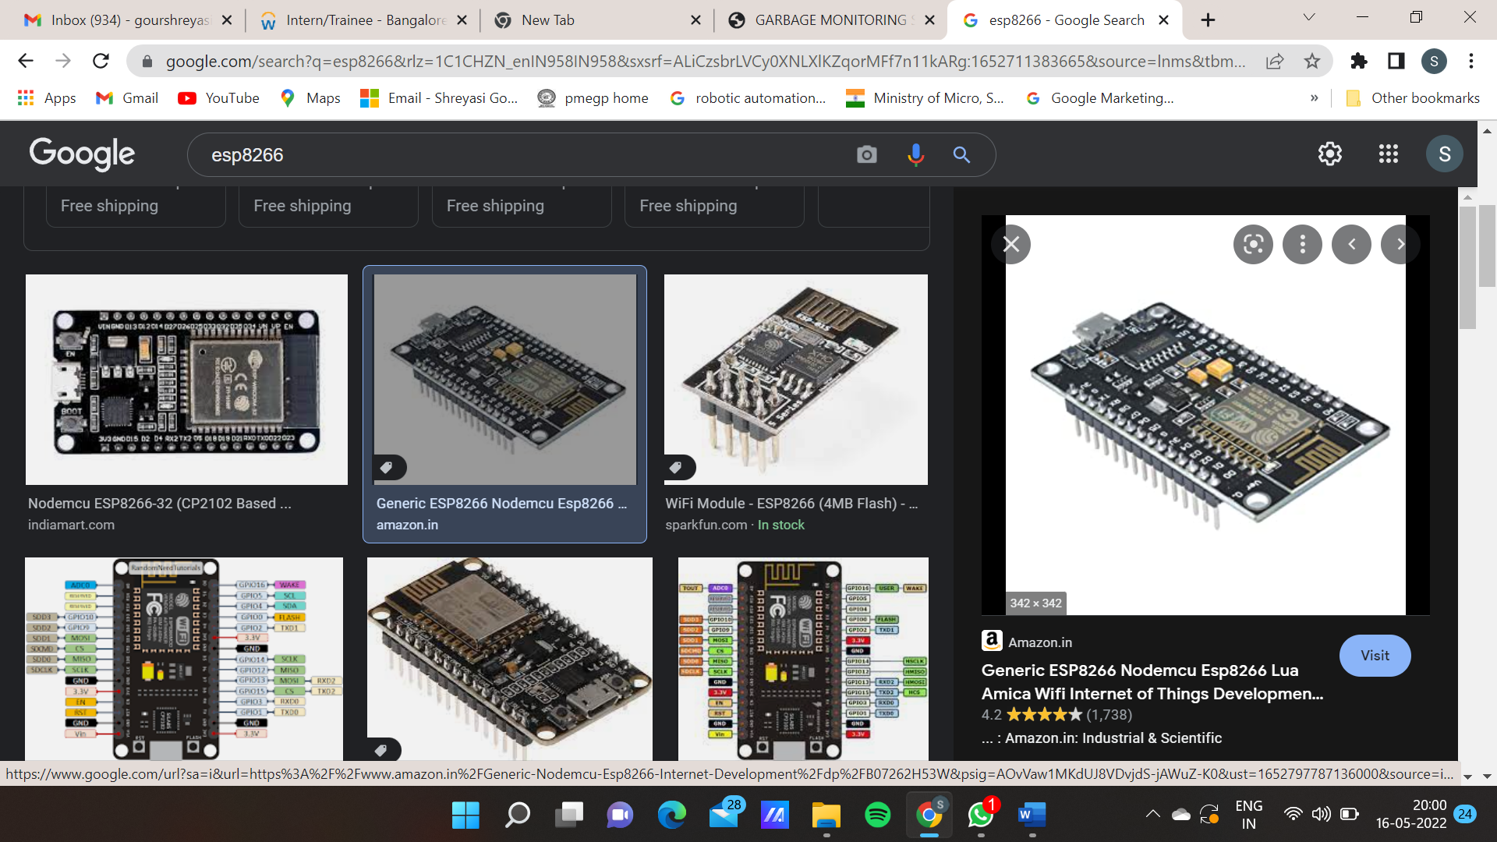  
Fig 3: NodeMCU ESP8266

## ULTRASONIC SENSOR

The Ultrasonic Sensor is used to measure the distance with high accuracy and stable readings. It can measure distance from 2cm to 400cm or from 1 inch to 13 feet. It emits an ultrasound wave at the frequency of 40KHz in the air and if the object will come in its way then it will bounce back to the sensor. By using that time which it takes to strike the object and comes back, you can calculate the distance. Distance can be measured by equation 1. Distance = Time * sound speed /2. (1) Where Time = the time between an ultrasonic wave is received and transmitted. It has four pins. Two are VCC and GND which will be connected to the 5V and the GND of the Arduino while the other two pins are Trig and Echo pins which will be connected to any digital pins of the Arduino. The trig pin will send the signal and the Echo pin will be used to receive the signal. To generate an ultrasound signal, you will have to make the Trig pin high for about 10us which will send a 8 cycle sonic burst at the speed of sound and after striking the object, it will be received by the Echo pin. Ultra sonic sensor as shown in figure 4.

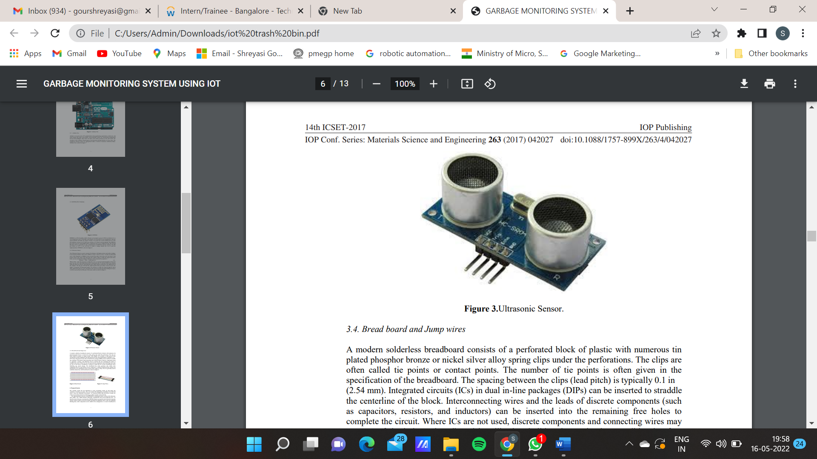  
Fig 4: Ultrasonic Sensor

## JUMPER WIRES

Jumper wires are simply wiring that have connector pins at each end, allowing them to be used to connect two points to each other without soldering. Jumper wires are typically used with breadboards and other prototyping tools in order to make it easy to change a circuit as needed. Jumper wires typically come in three versions: male-to-male, male-to-female and female-to-female. The difference between each is in the end point of the wire.

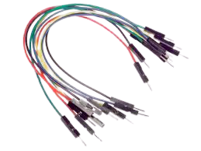

Fig 5: Jumper Wires

**5.4 SERVO MOTOR**

A servo motor is **a rotary actuator that allows for precise control of angular position**. It consists of a motor coupled to a sensor for position feedback. It also requires a servo drive to complete the system. The drive uses the feedback sensor to precisely control the rotary position of the motor.

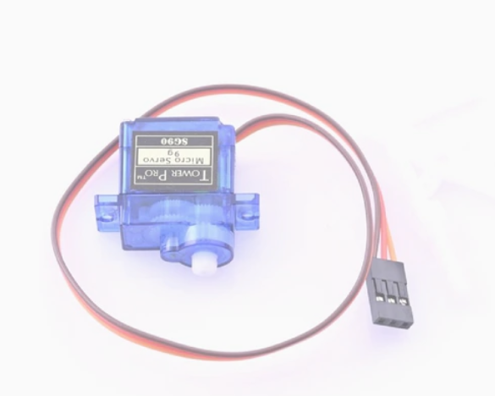

Fig 6. Servo Motor

# SOFTWARE

## ARDUINO 1.8.9

The Arduino Integrated Development Environment - or Arduino Software (IDE) - contains a text editor for writing code, a message area, a text console, a toolbar with buttons for common functions and a series of menus. It connects to the Arduino and Genuino hardware to upload programs and communicate with them.

Arduino is an open-source electronics platform based on easy-to-use hardware and software. Arduino boards are able to read inputs - light on a sensor, a finger on a button, or a Twitter message - and turn it into an output - activating a motor, turning on an LED, publishing something online. You can tell your board what to do by sending a set of instructions to the microcontroller on the board. To do so you use the Arduino programming language (based on Wiring), and the Arduino Software (IDE), based on Processing.

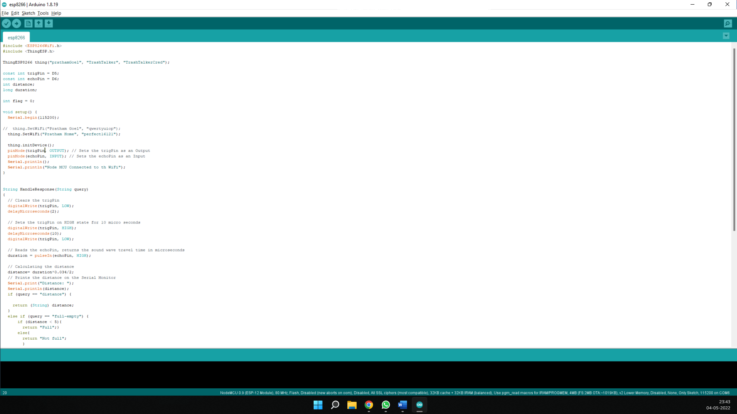

## BLYNK APP

Blynk is a new platform that allows you to quickly build interfaces for controlling and monitoring your hardware projects from your iOS and Android device. After downloading the Blynk app, you can create a project dashboard and arrange buttons, sliders, graphs, and other widgets onto the screen. Using the widgets, you can turn pins on and off or display data from sensors.

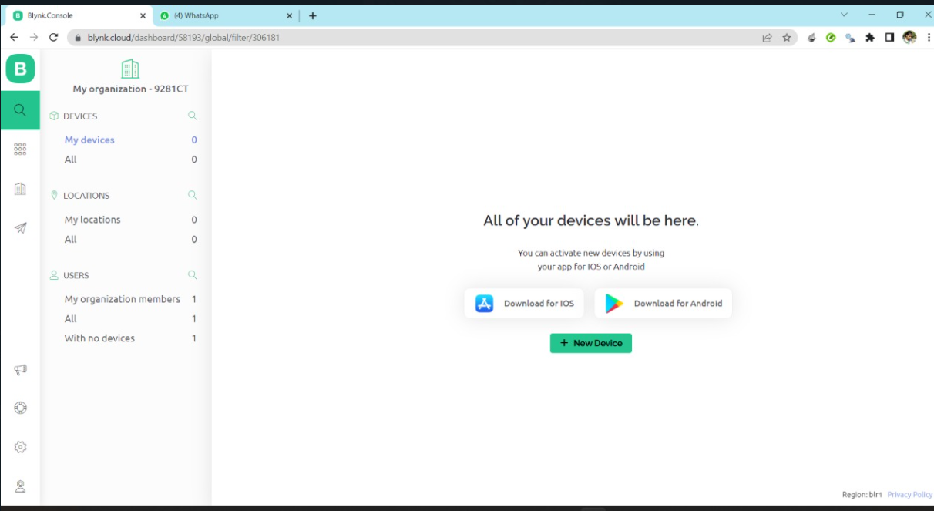

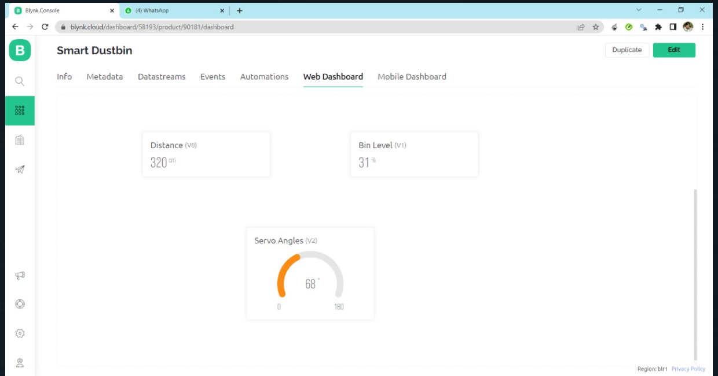

# SOFTWARE INSTALLATION

1. Download Arduino IDE for your system as per your operating system.

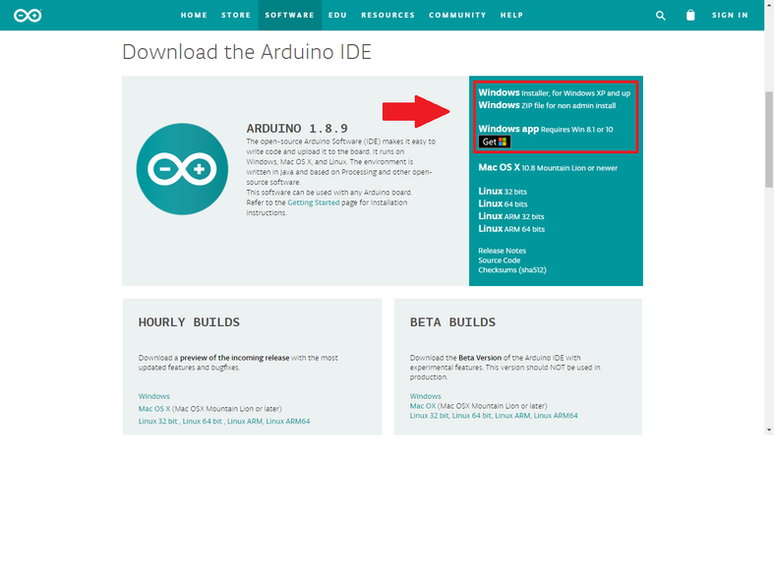

1. 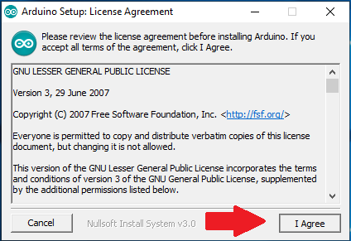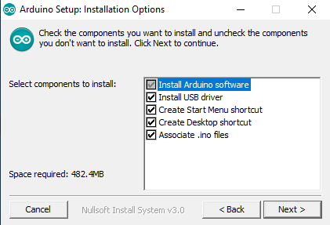Install the software

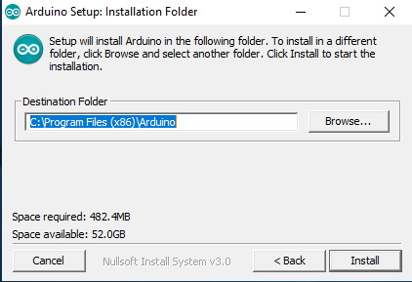

1. Create a new file and start coding

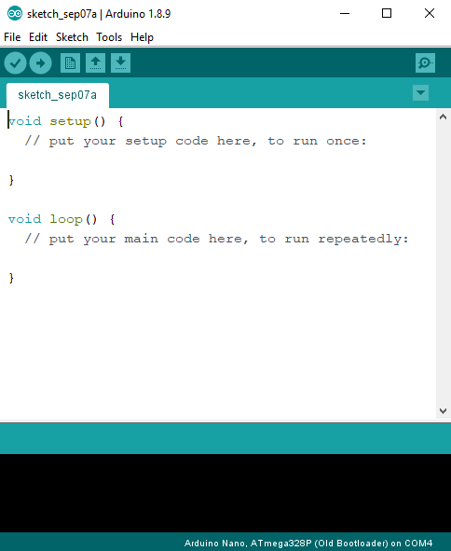

# TESTING OF COMPONENTS

1. NodeMCU

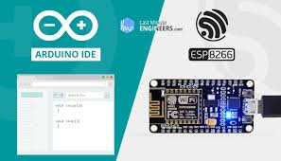

1. UltraSonic Sensor

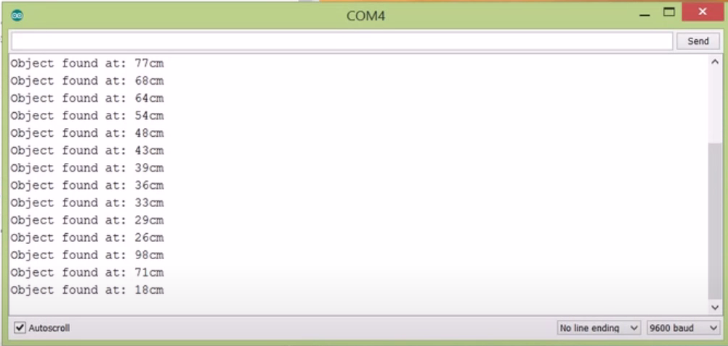

# PROBLEMS FACED

1. At the beginning of the project, we purchased ESP 8266 Wi-fi Module which was not able to connect to the internet service. To resolve this, we shifted the wi-fi module to NodeMCU which combined the use of Arduino uno and the wi-fi module.
2. At the beginning of the project, we were using both, NodeMCU and Arduino uno, hence requiring two power sources, but gradually we came to know that connections can be directly made from NodeMCU to the sensor. Now we only require one power source for NodeMCU.
3. Unavaliablity of 4 pin IR sensor in the market

# EXPERIMENTATION

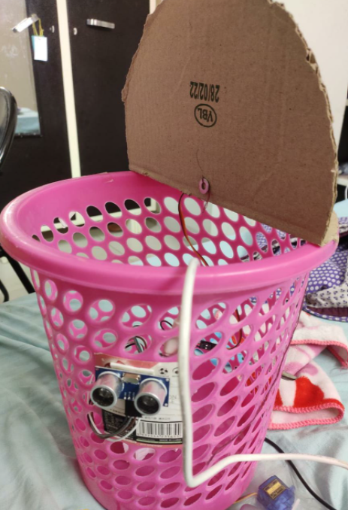 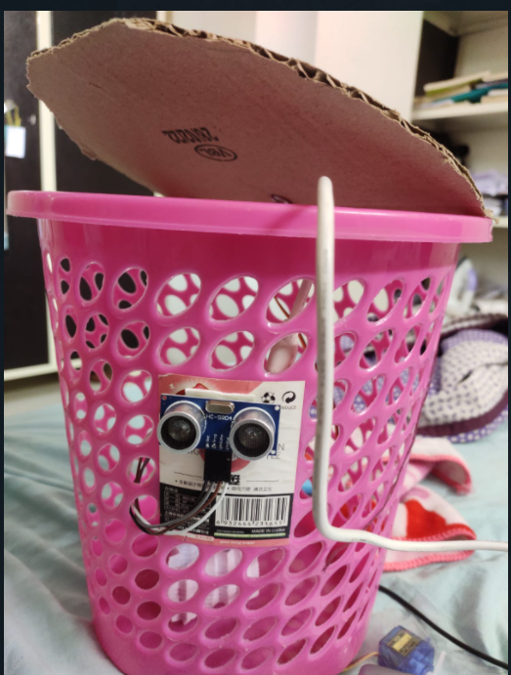

# APPENDIX

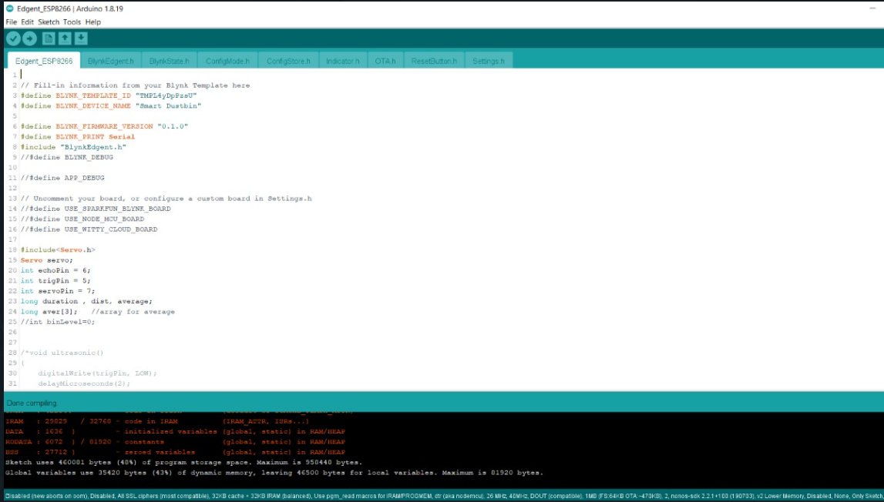

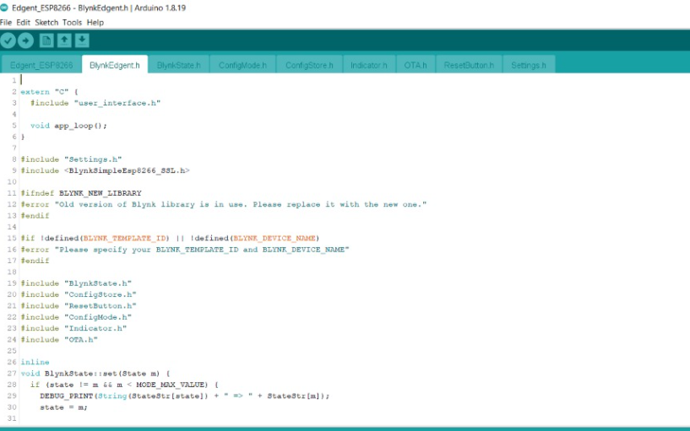

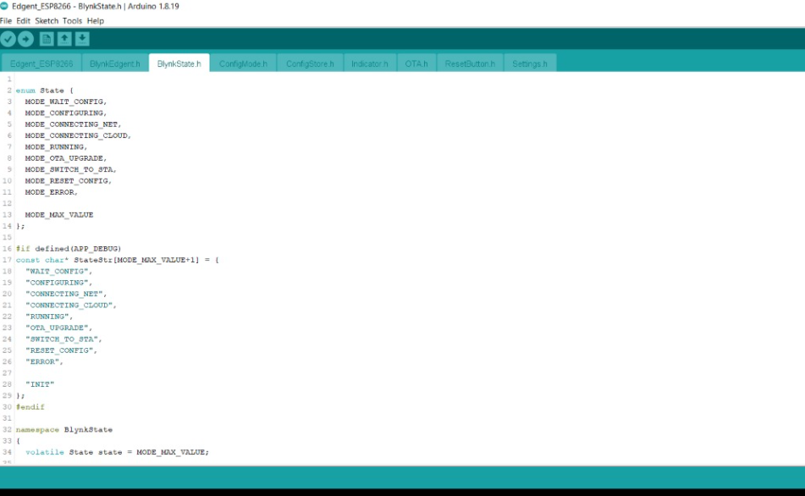

# CONCLUSION

The main objective is to maintain the level of cleanliness in the city and form an environment which is better for living. By using this system we can constantly check the level of the garbage in the dustbins which are placed in various parts of the city. If a particular dustbin has reached the maximum level then the employees can be informed and they can immediately take certain actions to empty it as soon as possible also it would avoid contact with the dustbin as it will automatically open the lid also giving us data about the degree of motor rotation and the distance between the trash and the bin. This can prove to be a very useful system if used properly. The system can be used as a benchmark by the people who are willing to take one step further for increasing the cleanliness in their respected areas. Ultrasonic sensor is being used in this system to check the level of garbage in the dustbins but in future various other types of sensors can be used with the ultrasonic sensor to get more precise output and to take this system to another level. Now this system can be used in certain areas but as soon as it proves its credibility it can be used in all the big areas. As this system also reduces manual work certain changes can be done in the system to take it to another level and make it more useful for the employees and people who are using it. In future, a team can be made which will be in charge for handling and maintaining this system and also to take care of its maintenances.

# REFERENCES

1. <https://create.arduino.cc/projecthub/bolt-iot-developers-u-p-region/trash-talker-using-bolt-iot-f2af5e>
2. <https://thingesp.siddhesh.me/#/console/project/TrashTalker>’
3. <https://console.twilio.com/?frameUrl=%2Fconsole%3Fx-target-region%3Dus1>